https://www.usdigital.com/products/encoders/incremental/kit/E6
E6 Optical Kit Encoder
I was thinking that this would be the configuration to define when ordering.
(E6-2000-250-IE-D-E-M-B) Price: $95.00

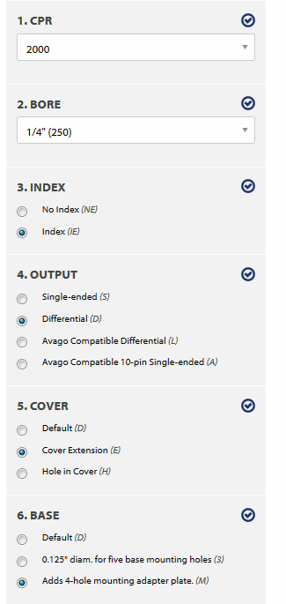
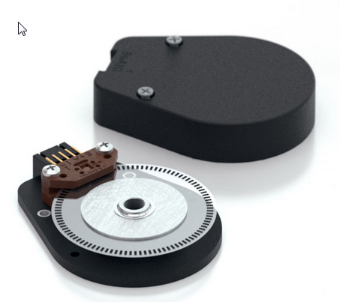

E6 Features
- Quick, simple assembly and disassembly
- Rugged screw-together housing
- Positive latching connector
- Accepts .010 in. axial shaft play
- 64 to 10,000 cycles per revolution (CPR)
- 256 to 40,000 pulses per revolution (PPR)
- 2 channel quadrature TTL squarewave outputs
- Optional index (3rd channel)
- Fits shaft diameters from 2mm to 1 in.

https://www.usdigital.com/products/accessories/cables/CA-FC10-SH-NC
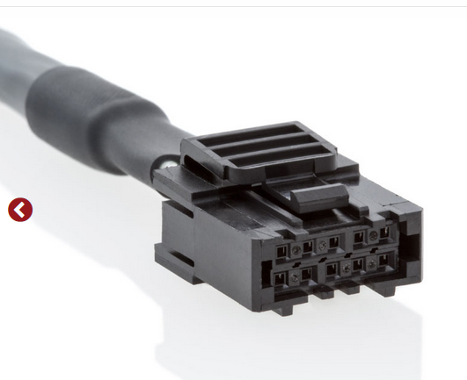
8 feet long: CA-FC10-SH-NC-8
Price: $20.60

